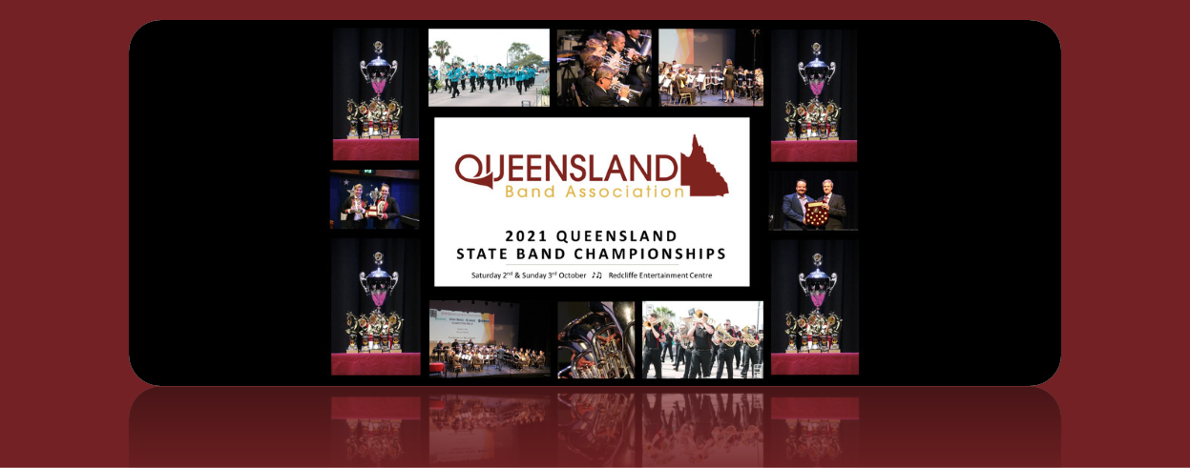
2021 Queensland Band Championships
DATE OF COMPETITION: 2 & 3 October 2021 • Venue: Redcliffe Entertainment Centre
PROGRAM OF EVENTS

Saturday 2 October | 8:30am | - Parade of Bands – Redcliffe Esplanade
 | 9:30am | - Junior, D, C, B, A Grade – Test Selection & Sacred Item
 | 5:00pm | - Concert Band Festival
Sunday 3 October | 9:00am | - Junior, D, C, B, A Grade – Own Choice & Stage March
*Exact times and scheduling will be released after the closing dates.

Entries Close: 07 August 2021 (8 weeks prior)
Player Registrations (ONLINE) Close: 21 August 2021 (42 Days prior)
Own Choice Music to QBA Secretary by: 4 September 2021 (4 weeks prior)
Permit Player Applications to QBA Registrar by: 11 September 2021 (3 Weeks Prior)
TEST SELECTIONS
A Grade Brass | Variations on a 9th | Gilbert Vinter
B Grade Brass | Princethorpe Variations | Kenneth Downie
C Grade Brass | Oceans | Goff Richards
D Grade Brass | Pageant | Barrie Gott
Junior Brass | Own Choice
A Grade Concert | 2nd Suite in F | Gustav Holst
B Grade Concert | Moorside Suite | Gustav Holst
C Grade Concert | Academic Festival Overture | Brahms arr Curnow
D Grade Concert | Own Choice

For contest rules and regulations, test selections and contact information, please go to www.qba.org.au.

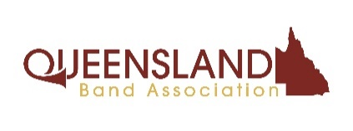
2021 Queensland Band Championships
ENTRY FORM – ALL BANDS

ENTRIES CLOSE: 07 August 2021
Strictly one entry (one band) per form

Sacred/Reflective Item; Test; Own Choice Selection; Stage March & Parade of Bands
Association Name:
Band: | Grade:
Postal Address:
Secretary Email: | (Sec) Phone:

Entry Fees:
- A, B, C & D Grades - $350
- Junior Grade - $250
- School Bands - $100
- All player registrations need to be completed using www.qba.org.au via the secretary portal. All players must be registered 42 Days prior to contest
- Adjudicators' copies of all Own Choice Music must be submitted by 4 September 2021 to:
The QBA Secretary: PO Box 8262, Sunnybank, QLD. 4109
- Completed Permit Application Forms must be submitted by 11 September 2021 to:
The QBA Registrar: qldbands@gmail.com

Secretary Signature: | Date:

This form must be attached to the band’s Contest Entry Summary Form with a cheque/direct deposit receipt number for the appropriate fees and sent to: QBA Secretary, PO Box 8262, Sunnybank QLD 4109
Fees can be deposited to: Queensland Band Association BSB: 124 021 Acc: 1000 6159
Mail cheque / form to: The QBA Secretary, PO Box 8262, Sunnybank QLD 4109

2021 Queensland Band Championships
SUMMARY FORM - ENTRIES
COMPETITION: Queensland State Band Championships 2021
DATE OF (BAND) COMPETITION: 2 & 3 October 2021 CLOSE OF ENTRIES: 07 August 2021
- This form to be attached at the front of all other entry forms and accompanied by payment covering total entry fees.
- PLEASE NOTE: The QBA invites volunteers from your organisation to help out over the weekend. We have allowed space for this information below. Thank you for your support.
(Please print clearly all details in full)
Association OR School Name:
Postal Address:
City / Postcode: | Secretary Name:
Secretary Email: | Secretary phone:
Musical Director: | MD phone:
Drum Major: | DM phone:
Volunteer/s (Optional): | Email OR phone:

EVENT | No of Bands | Fee per band | Player Pass Bundle/s  QTY ($100 ea.)* | TOTAL
Bands – A,B,C & D Grades |  | $350.00 | * | $
Bands – Junior Grade |  | $250.00 | * | $
School Band |  | $100.00 | * | $
Please indicate quantity of Player Pass Bundle/s required in column marked with * |  |  | TOTAL PAID: $
Secretary Signature: |  |  | Date:
* PLAYER PASSES: A flat fee of $100 (in addition to entry fee/s) will provide competitor bands with player passes equal to the number of active players registered with the QBA Registrar. Limits apply to both brass and concert bands. This is payable BEFORE the contest, for bands wishing to have passes for the whole band. Individual players can purchase at the door ($6 each), however “whole band” bundles will not be available for purchase, after the start of the contest. Please indicate the quantity of bundles required for your band/s in the table above marked with *
This form must be attached to all other forms and be accompanied by payment of entry fees.
Upon completion, this form becomes a tax invoice

2021 Queensland Band Championships
MUSIC SUMMARY FORM
BANDS - Own Choice Music Schedule
COMPETITION: The Queensland Band Championships
DATE OF COMPETITION: 2 & 3 October 2021

Band name: | Grade:
Secretary: | Secretary Contact Phone:

Event | Title | Composer/Arranger | No of Bars | Performance Time | Bars Numbered | No marks | Pages bound
Street March
(40 points)
Sacred/ Reflective Item
(100 points)
Own Choice Selection
(200 points)
Stage March
(100 points)

All Adjudicator copies must be RECEIVED BY* Saturday 4 September 2021 to:
The QBA Secretary, PO Box 8262, Sunnybank QLD. 4109

*Express Post is recommended, to ensure they arrive on time. Extensions not permitted.
For contest rules and regulations, test selections and contact information, please go to www.qba.org.au.

